Generate Paranthesis
Problem Statement: Given n pairs of parentheses, write a function to generate all combinations of well-formed parentheses.
Example 1:
Input: n = 3
Output: ["((()))", "(()())", "(())()", "()(())", "()()()"]

Example 2:
Input: n = 1
Output: ["()"]
Algorithm
- Start with an empty string curr = "".
- Initialize counters: open = 0, close = 0.
- If open < n, add '(' and recurse.
- If close < open, add ')' and recurse.
- If curr.length == 2 * n, add it to the result.
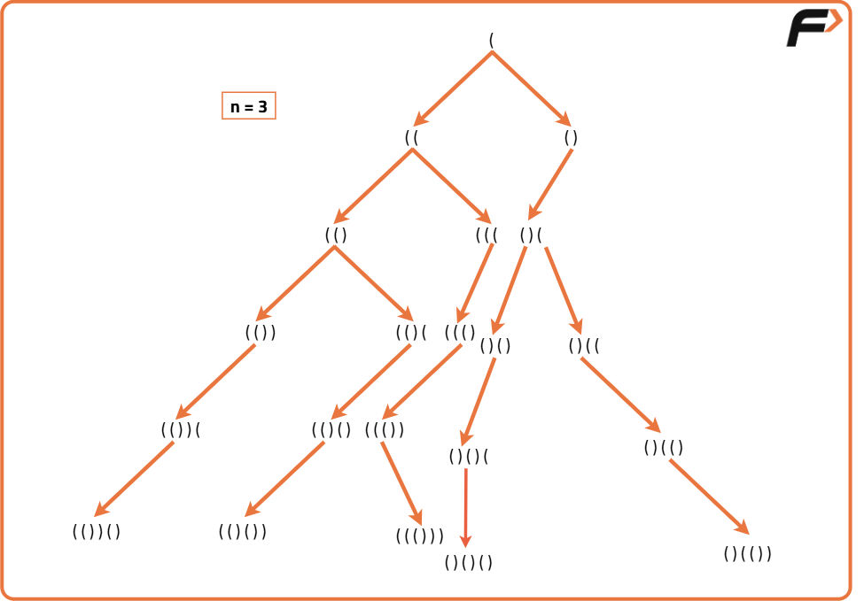
import java.util.*;

class OptimalSolution {
public void backtrack(String curr, int open, int close, int n, List<String> res) {
if (curr.length() == 2 * n) {
res.add(curr);
return;
}
if (open < n) backtrack(curr + "(", open + 1, close, n, res);
if (close < open) backtrack(curr + ")", open, close + 1, n, res);
}
public List<String> generateParenthesis(int n) {
List<String> res = new ArrayList<>();
backtrack("", 0, 0, n, res);
return res;
}
}
Time Complexity: O(2^n) (Catalan number): C(n) = (2n)! / (n!(n+1)!) is the number of valid sequences.
Each sequence takes O(n) to build.
So, total complexity: O(C(n) × n)
Space Complexity: O(n) recursion depth.
O(C(n) × n) to store results.

